**Name**: Mohamed essam Ibrahim abd elhafz elkordy الاسم: محمد عصام إبراهيم عبد الحافظ الكردي

**B.N**/762

**Topic**: Artificial Intelligence

**Application brief**

Artificial Intelligence (AI) | the ability of a digital computer or computer-controlled robot to perform tasks commonly associated with intelligent beings. AI is wide-ranging branch of computer science concerned with building smart machines capable of performing tasks that typically require human intelligence.

AI is ubiquitous today, used to recommend what you should buy next online, to understand what you say to virtual assistants such as Amazon's Alexa and Apple's Siri, to recognize who and what is in a photo, to spot spam, or detect credit card fraud.

"Artificial Intelligence examples: Smart assistants, Manufacturing and drone robots, Song or TV show recommendations, Conversational bots for marketing and customer service, Disease mapping and prediction tools and google map.

The use of artificial intelligence applications has revolutionized all areas and is constantly evolving

**Screenshots**:

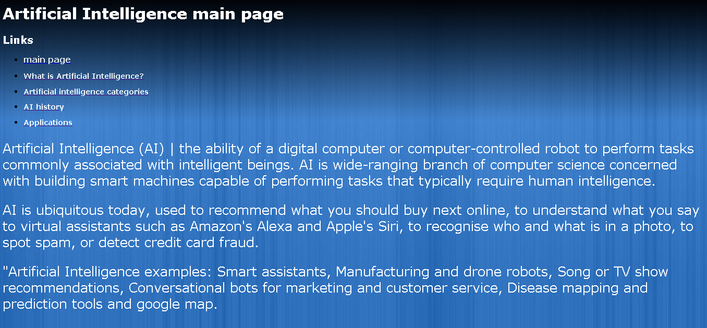

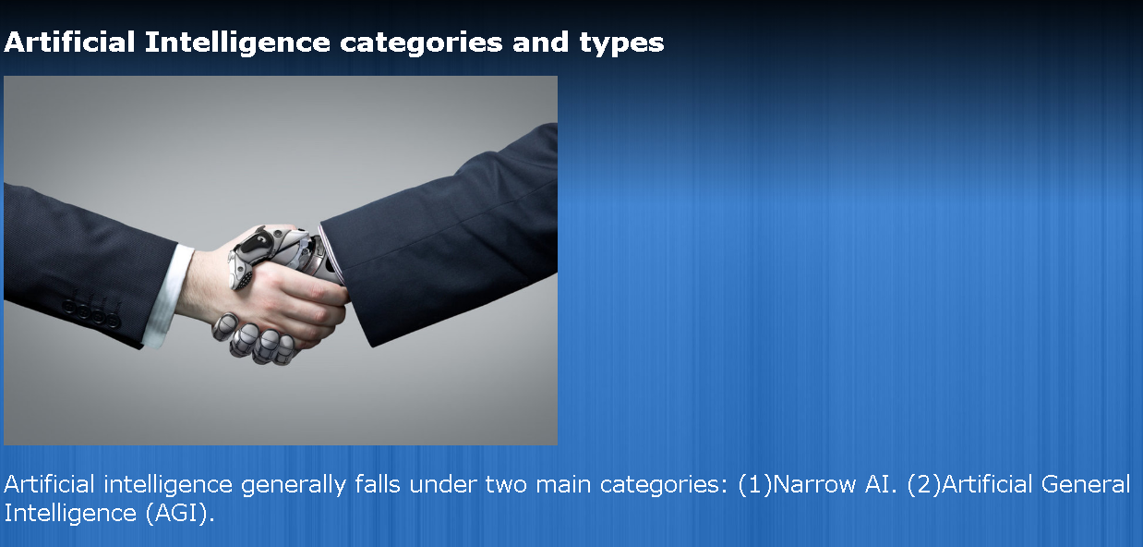

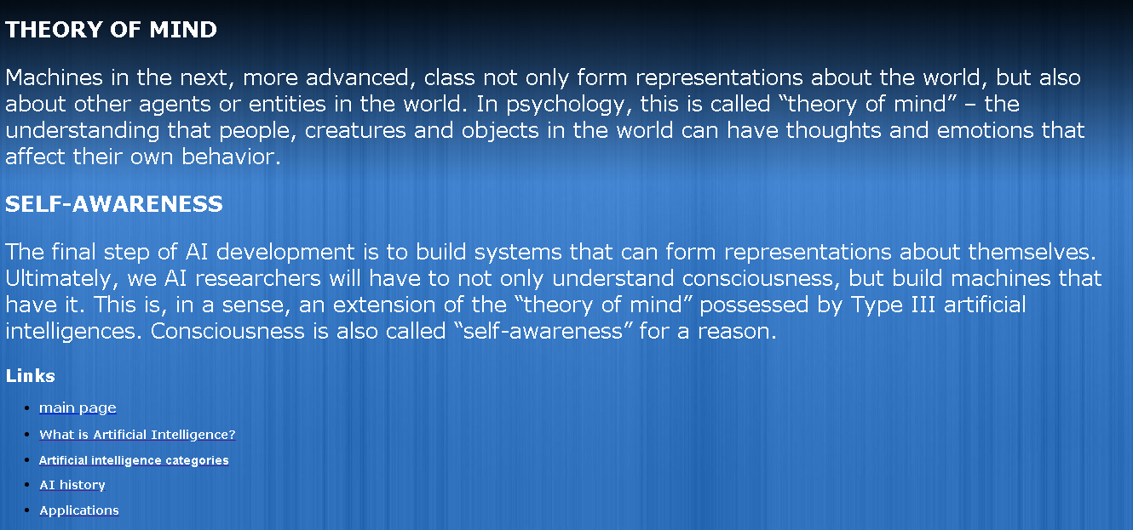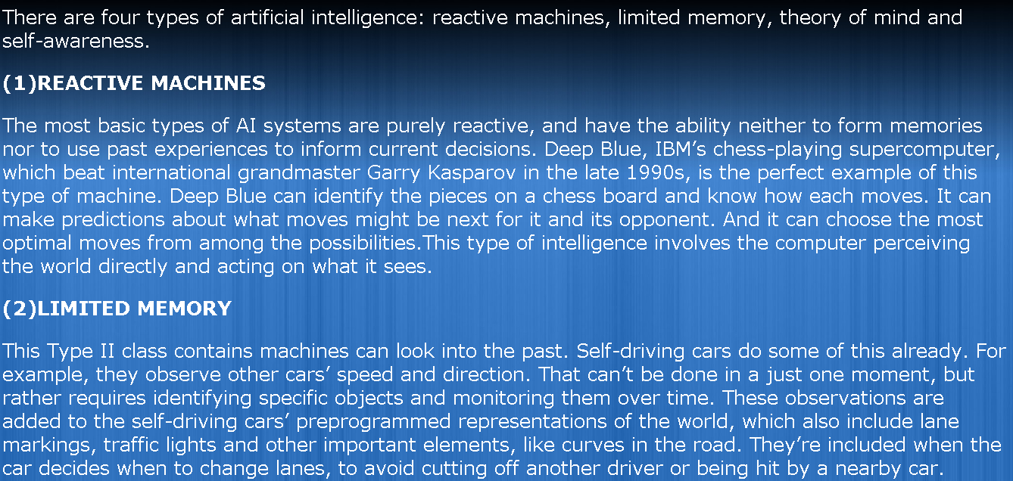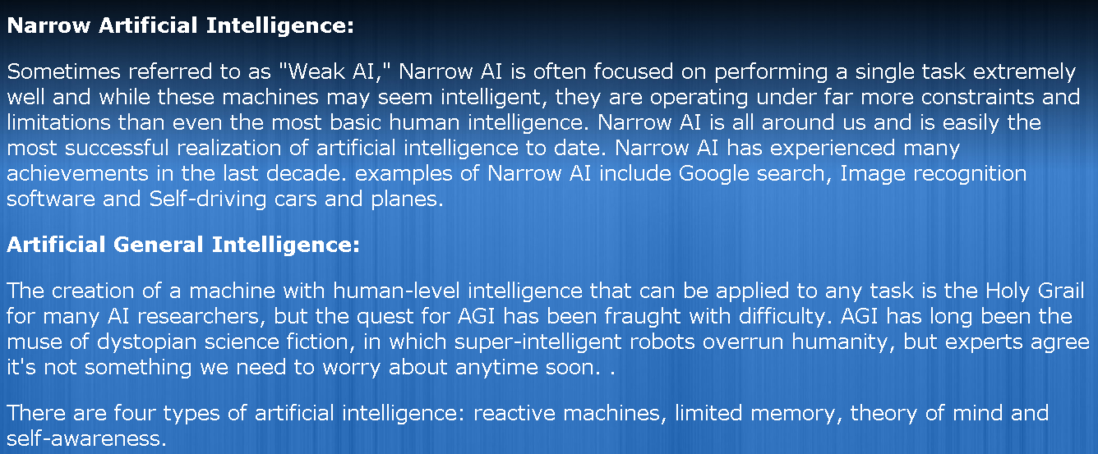

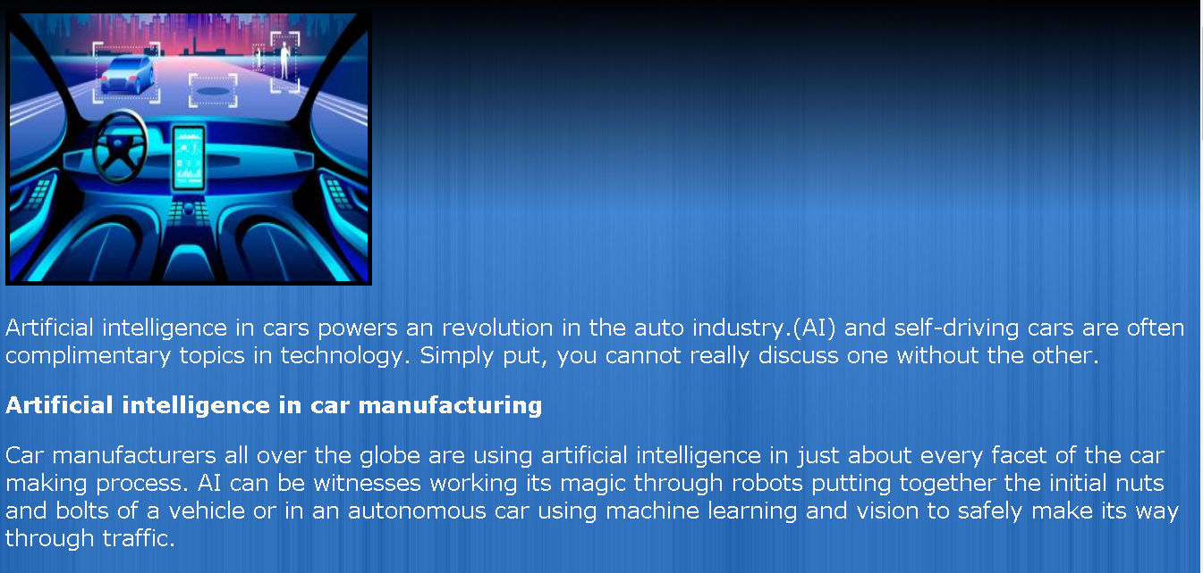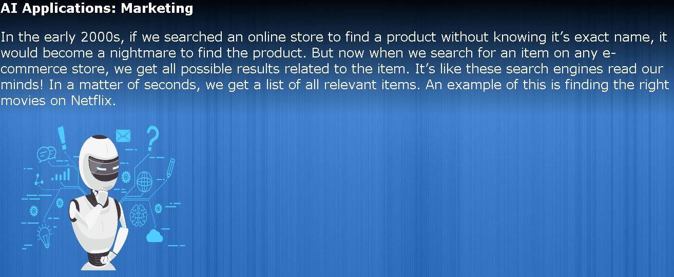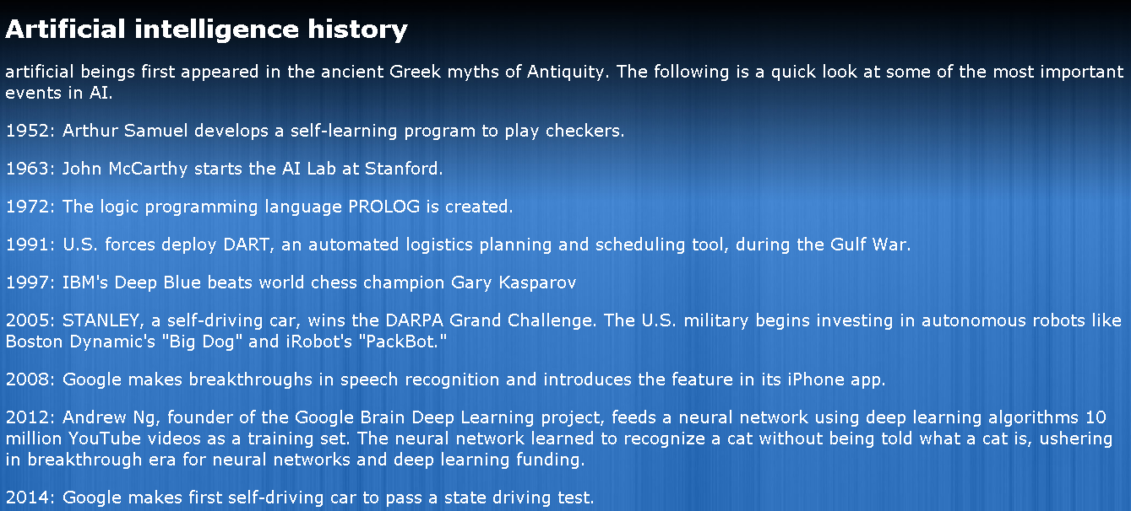

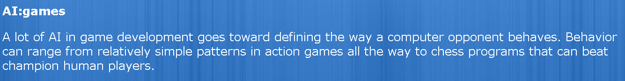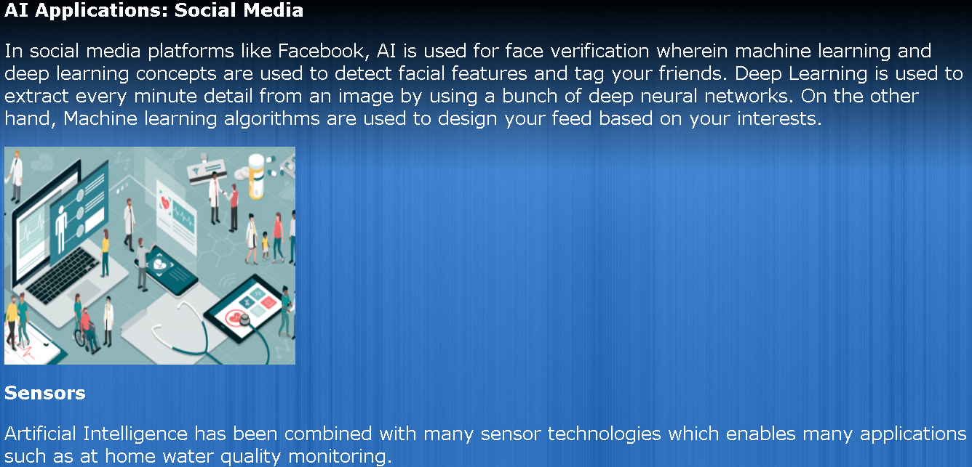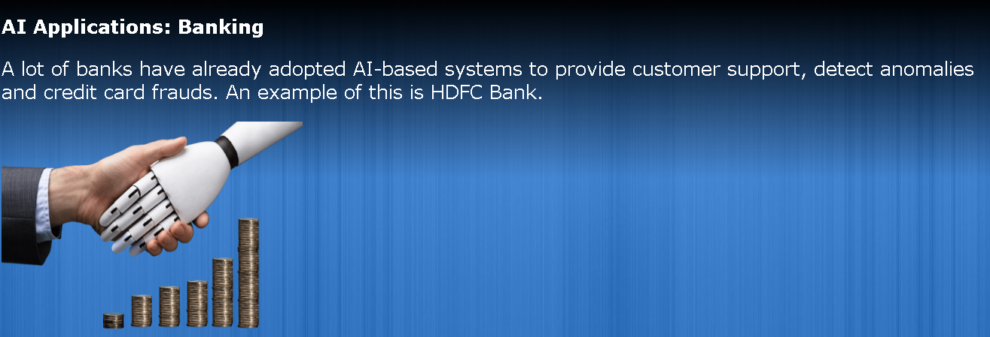

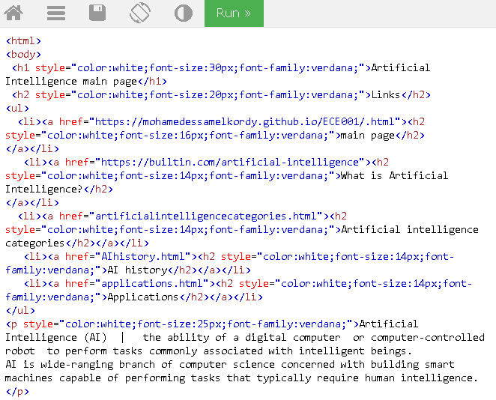Source code:

